**Nov 2016 HL P1**

**Section A**

1. State **three** potential usability issues with cell phones. [3]

*Award up to* ***[3 max]****.*

Has a small (touch-sensitive) screen;

Uses batteries for power;

No hard disk drive / small memory;

Reliability / Network coverage issues;

Over in warm weather;

Too many steps to access a particular feature;

*etc*.

1. (a) State the purpose of cache memory. [1]

Is used to save time in accessing RAM;

(b) Draw a diagram to show the relationship between random access memory (RAM), the processor   
 and cache memory.

*Award* ***[1]*** *for the cache between RAM and the processor.*

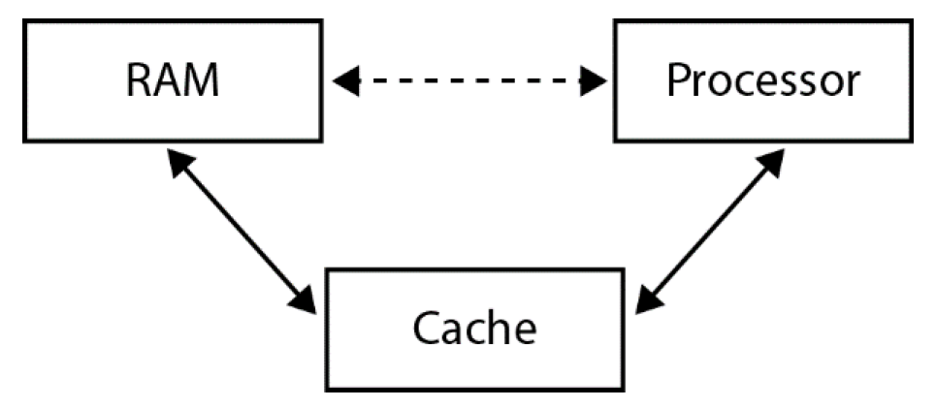

1. Outline **one** advantage and **one** disadvantage of wireless networks. [4]

*Award* ***[1]*** *for stating an advantage and* ***[1]*** *for an expansion.*

*Award* ***[1]*** *for stating a disadvantage and* ***[1]*** *for an expansion.*

Advantages and disadvantages such as:

• Ease of use for mobile users

• Connectivity between different locations

• Reliability

• Cost

• Security

• Change in working patterns

• Health issues

*etc*.

*Example answer:*

*Advantage*:

Ease of use for mobile users;

As they can work in many different locations;

*Disadvantage*:

Security issues;

As wireless transmissions are easily intercepted;

1. Construct a truth table for the Boolean expression not (A xor B) and C.

Use the following headings in your table.

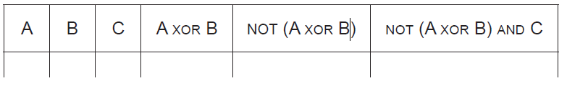 [4]

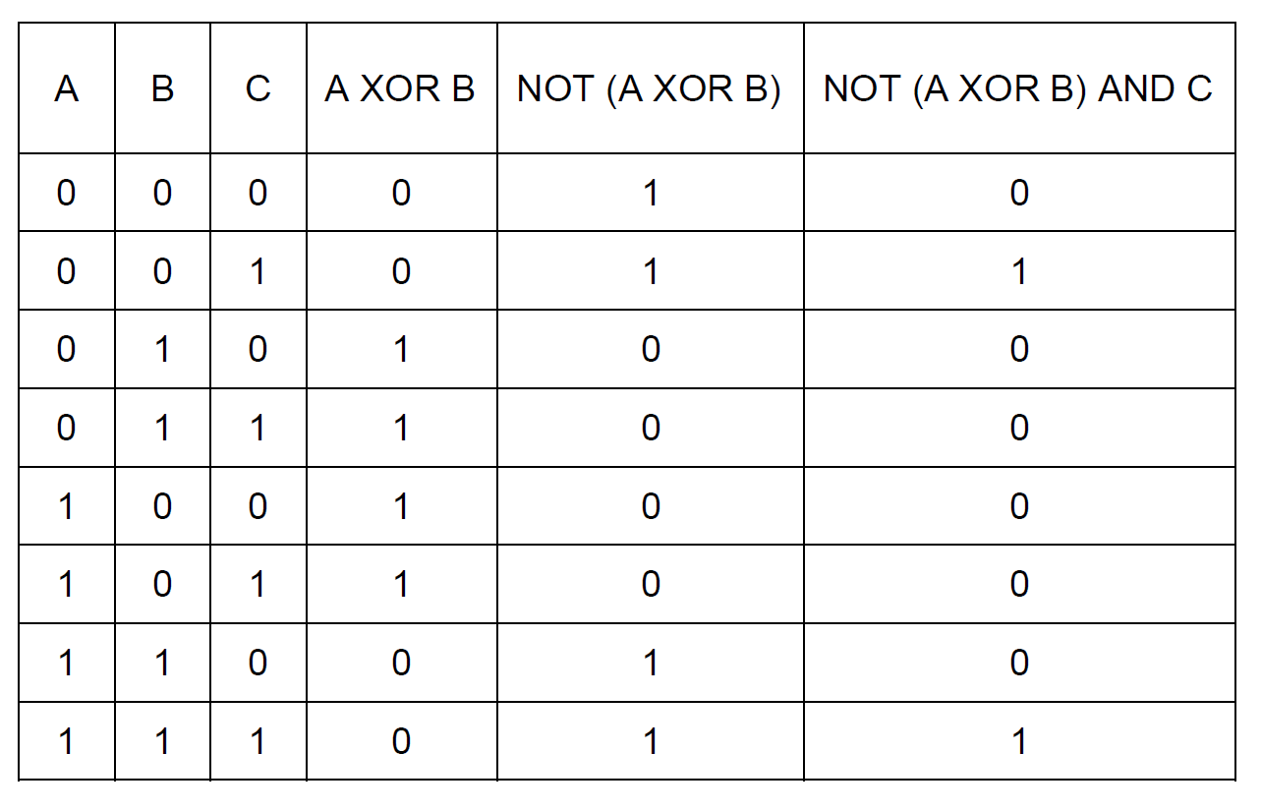

*Award up to* ***[4 max]*** *as follows.*

*Award* ***[1]*** *for all 8 sets of input values correct.*

*Award* ***[1]*** *for correct A XOR B column.*

*Award* ***[1]*** *for correct NOT (A XOR B) column.*

*Award* ***[1]*** *for correct NOT (A XOR B) AND C column.*

1. Many different people and organizations upload scientific materials to the internet.

A student uses data from the internet in a science project.

Outline **two** ethical issues concerning this use of the internet. [4]

*Award* ***[1]*** *for an ethical issue,* ***[1]*** *for an explanation, for two issues up to* ***[4 max]****.*

*Points to be discussed:*

The data/information is deliberately incorrect;

The data/information has not been validated;

Intellectual property issues;

Plagiarism;

1. Consider the following recursive algorithm FUN(X, N), where X and N are two integers.

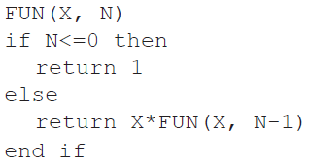

The return statement gives the value that the algorithm generates.

1. Determine how many times multiplication is performed when this algorithm is executed. [1]

N;

1. Determine the value of FUN(2,3), showing all of your working. [3]

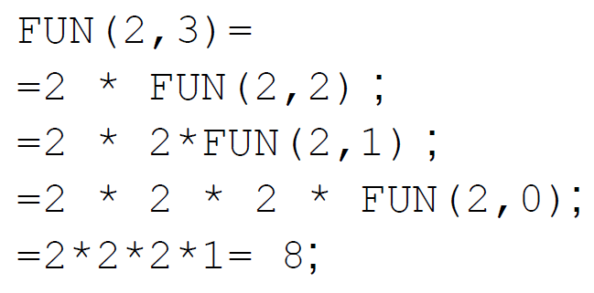

1. State the purpose of this recursive algorithm. [1]

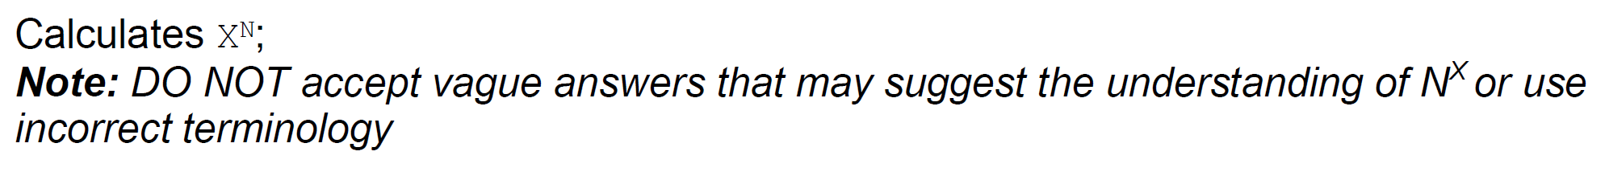

1. 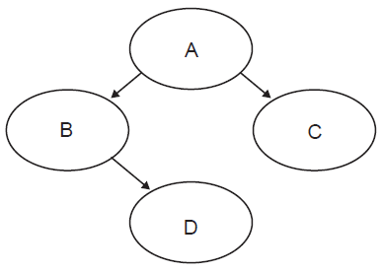Consider the following binary tree.
2. Identify all leaf nodes in this binary tree. [1]

D and C;

1. For this binary tree, state the result of:
2. inorder tree traversal, [1]

B D A C;

1. postorder tree traversal. [1]

D B C A;

**Section B**

1. A book shop has a computer at each point of sale, and also a central computer.

When a customer buys a book in the book shop, the salesperson at the point of sale uses a

scanning device to input a barcode from the book.

The barcode is sent to the central computer where the barcode of each book and the

corresponding price are held in a database on a disk.

When the price is found, it is sent to the point of sale computer where all necessary

calculations are performed, details of the transaction are stored on a local disk and a receipt

is printed out.

1. Construct a system flow chart for the system described above. [5]

*Award* ***[1]*** *for all correct labels or symbols.*

*(Accept meaningful, consistent symbols.)*

*Award* ***[1]*** *for correct input flow.*

*Award* ***[1]*** *for correct output flow.*

*Award* ***[1]*** *for correct internal processes.*

*Award* ***[1]*** *for correct dataflow.*

*Answers given as a process flowchart may still be awarded* ***[1]*** *or* ***[2]****.*

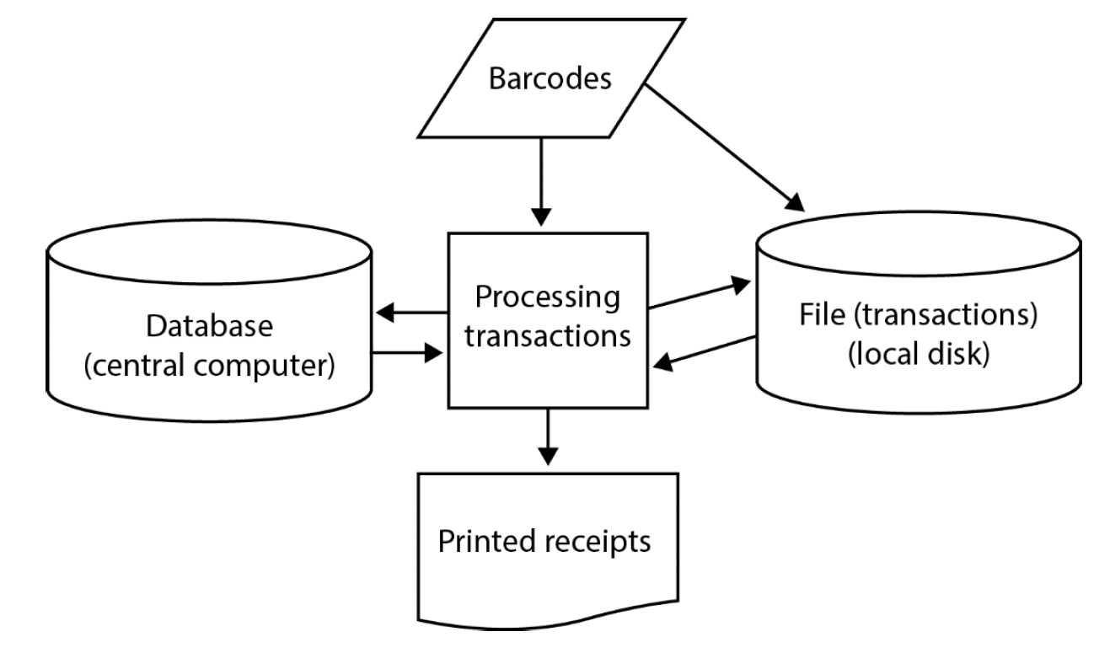

At the point of sale there are peripheral devices other than the scanning device and printer.

1. Outline the purpose of one other possible peripheral device in this scenario. [2]

*Award* ***[1]*** *for identifying a peripheral device,* ***[1]*** *for stating its purpose.*

*Example answers:*

Keyboard;

To type in some additional data;

Or to type in barcode data when it is not possible to scan;

Magnetic card reader;

Used when a credit card is used;

Microphone;

To call the next customer;

To call manager;

Monitor;

So the salesman can see the information/data on the screen;

Visual display;

So the customer can read the information/data on the display;

Speakers;

For customers to hear information;

For shop assistants to bring another item the customer may wish to buy;

The customers can also buy books online. A customer can select a book, and then enter  
 their name, address and credit card number. This data is stored on the book shop’s  
 central computer in a database of customer orders.

1. Outline the purpose of protocols in transferring this data. [2]

*Award up to* ***[2 max]****.*

Protocols are sets of rules for transmitting data correctly;

They ensure that data is sent from a customer's computer and received by the shop’s computer;

To create a secure transmission of data from the client to the server through the use of the Hypertext Transfer Protocol (HTTPS) *ie* the customer can pay for the books securely (using TLS or SSL).

1. (i) Identify two sources of risk to personal data in this online system. [2]

*Award up to* ***[2 max]****.*

Protocols are sets of rules for transmitting data correctly;

They ensure that data is sent from a customer's computer and received by the shop’s computer;

To create a secure transmission of data from the client to the server through the use of the Hypertext Transfer Protocol (HTTPS) *ie* the customer can pay for the books securely (using TLS or SSL).

(ii) State two measures that the book shop can take to address the risks identified

in part (d)(i). [2]

*Award up to* ***[2 max]****.*

All private information must be encrypted;

Transmission channel must be protected by encryption;

Logging on to the system must be secured (to prevent intruders);

Dual data back-up system in case of accidental deletion;

(iii) Outline the consequences to the customer if their data is not adequately protected. [2]

*Award up to* ***[2 max]****.*

Details stolen;

Used for fraudulent purposes;

Contact details could be shared;

Used for junk mail/fraud;

Personal details stolen;

For identity theft;

1. A new higher level programming language is being developed.
2. Identify **two** reasons why consistent grammar and syntax should be essential features

of a higher level programming language. [2]

*Award up to* ***[2 max]****.*

Easy to learn/use;

Otherwise time may be wasted learning the new language/writing programs in

this HLL;

There will be no/less compilation errors;

There will be no/less logical errors;

(Reduction of time to create software;)

Future maintenance/development is possible by other programmers;

1. Identify **two** features of a user interface that will allow application programmers to

interact more easily with the programming language. [2]

*Award up to* ***[2 max]****.*

GUI;

Toolbars;

Menus;

Built in commands for inputting from touch screens;

Predicted text so that typing a class name followed by a full stop will bring up a list of methods/attributes;

Automatically use a colour to represent keywords/variables and improve readability

1. State one method of providing user documentation. [1]

*Award* ***[1 max]****.*

Help files;

Online support;

Application programmers who use this programming language will be able to choose to use  
 either an interpreter or a compiler.

1. (i) Outline the need for an interpreter or a compiler. [2]

*Award up to* ***[2 max]****.*

Must be translated from a higher level language understandable by humans/not understood by machines;

Must be translated into machine code;

For the CPU to execute it;

(ii) Describe one advantage to application programmers of having both an

interpreter and a compiler available. [2]

*Award up to* ***[2 max]****.*

Must be translated from a higher level language understandable by humans/not understood by machines;

Must be translated into machine code;

For the CPU to execute it;

One of the predefined sub-programs in the new language is sumOdd(). It accepts an integer  
 N as input. If N<=0 it outputs -1, otherwise it outputs the sum of the first N odd numbers.

For example:

sumOdd(4) outputs 16, because 4 is not less than 0, and 1 + 3 + 5 + 7 = 16.

sumOdd(−3) outputs −1, because −3 is less than 0.

1. Construct, in pseudocode, the algorithm for sumOdd(). [4]

*Award marks as follows:*

*Award* ***[1]*** *for branch of if-then-else leading to correct computation of S=–1;*

*Award* ***[1]*** *for the correct loop (boundaries);*

*Award* ***[1]*** *for correctly calculating the sum;*

*Award* ***[1]*** *for the output;*

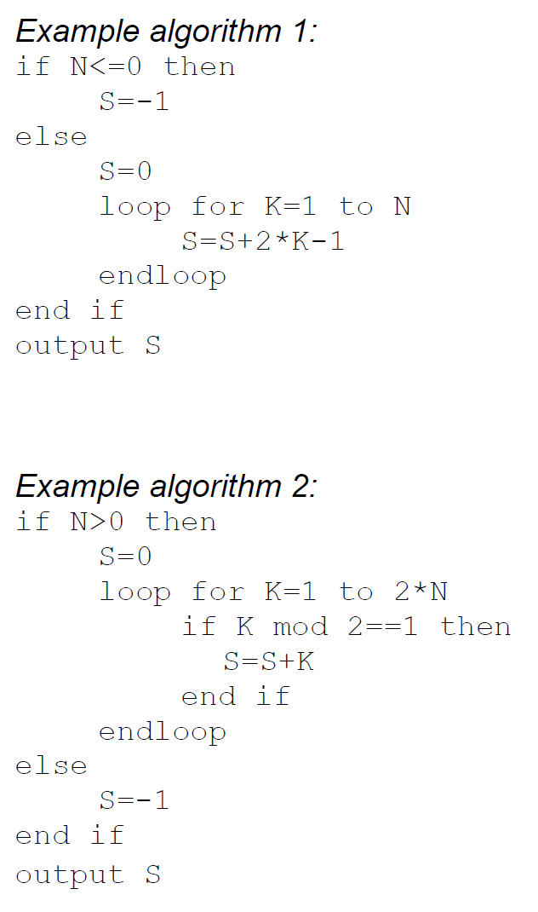

1. Outline the need for predefined sub-programs and collections. [2]

*Award* ***[1]*** *for any of the benefits listed below,* ***[1]*** *for an expansion (ie when/why/who will need it?).*

Reusability;

Modularity;

Reliability / All predefined sub-programs are tested and reliable;

*etc*.

*Example answer:*

Predefined sub-programs and collections are reusable;

And this reduces the cost/time needed to develop a large program;

1. The temperature, humidity, light levels and automatic watering of plants inside the

greenhouses (glasshouses) of a garden centre are centrally monitored and controlled.

1. Define the term analog data. [1]

Data represented by a continuous variable;

***Note:*** *Do not accept “not in digital format” or just examples.*

1. With reference to sensors, transducers and the processor, explain the control process

that takes place in the greenhouse (glasshouses). [5]

*Award* ***[1]*** *for outlining the purpose of each device, for all three devices.*

*Award* ***[2]*** *for explaining the importance of feedback in this relationship;*

*Example answer:*

Sensor: converts an inputted physical quantity (temperature, light, *etc*) into an electrical signal;

Processor: executes a set of instructions (programs) which control the

whole process;

Transducer: converts electrical signals into other forms of energy

(heat, light, *etc*);

Feedback: input signals (information about what is happening to a particular process in the greenhouses) is monitored;

And fed back to the processor where they can be used to make decisions whether to change/modify the climate in the greenhouses or not;

1. Outline the role of the operating system specific to this scenario. [4]

Operating system is a set of programs for this (dedicated) system;

Responsible for input devices (reading sensor data);

Responsible for sending to the output;

And reacting to inputted data in (predetermined) periods of time (to ensure the correct climate in the greenhouses);

***Note:*** *Correct answers must be specific to the scenario in question 10.*

1. Describe the difference between polling and interrupt in the event that some of the

sensors malfunction. [3]

*Example answer:*

*Polling:*

The CPU visits/checks each sensor in turn to see if there is some input data;

It will know that the sensor has malfunctioned;

*Interrupt:*

Each sensor sends data as required;

It will not know that the sensor has malfunctioned (unless a timer is set with a limit on the time between expected interrupts by a given sensor);

1. Compare a centrally controlled system with a distributed system. [2]

One computer/processor controls all the greenhouses;

Whilst in distributed system each of the greenhouses is monitored and controlled by its own computer;

1. The diagram shows a list of names held in a circular linked list. The end of the list is pointed

to by an external pointer, X.

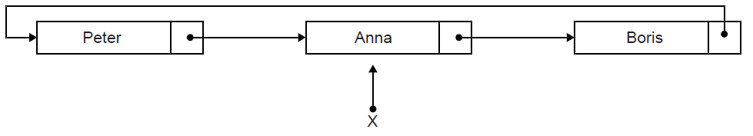

1. State the first name in this circular list. [1]

Boris;

Two operations are performed on the list in the following order:  
 1. A node containing the name Sarah is inserted at the beginning of the list.  
 2. A node containing the name Ken is inserted at the end of the list.

1. Sketch a diagram showing the resulting circular linked list. [3]

*Award up to* ***[3 max]****.*

*For the diagram showing all nodes and links;*

*Ken inserted after Anna AND Sarah placed after Ken;*

*Node containing Ken is pointed to by X/Ken is currently at the end of the list;*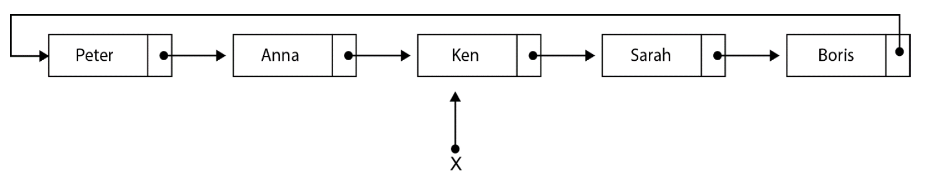

1. Describe how the number of names held in this list could be determined. [4]

Use a variable (counter) to keep track of/increment the number of nodes;

Use a temporary pointer;

Follow the pointers from the beginning of the list/from the node pointed to by pointer X.next;

Until the pointer to the end of the list (pointer X) is encountered;

***Note:*** *Accept methods that start from the end of the list (X).*

1. Explain how a stack could be used to output, in reverse order, all names held

in the linked list. [4]

Traverse the list from beginning to end;

**Pushing** each data value from the list onto the stack;

While stack is not empty;

**Popping** an element from the stack and output the stack element;

1. Compare the use of static and dynamic data structures. [3]

Static data structure has a predetermined number of elements but number of elements in dynamic data structure does not have to be defined in advance;

Static data structure has limited size, the amount of memory available is the only limit in size of dynamic data structure, size varies;

In static data structure elements can be directly accessed, in a dynamic data structure access is sequential (which is slower);

1. A two-dimensional array, A, has N rows and N columns, where N is a positive integer.

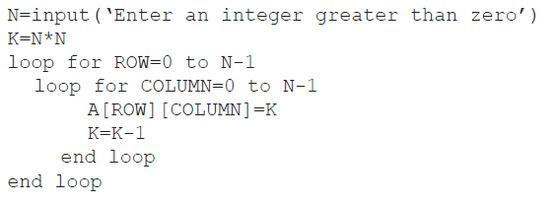The following algorithm is written to fill array A with the numbers 1, 2, 3,…, N2.

1. Trace the algorithm, with an input of N=3, to show the contents of array A after the

algorithm has been executed. [3]

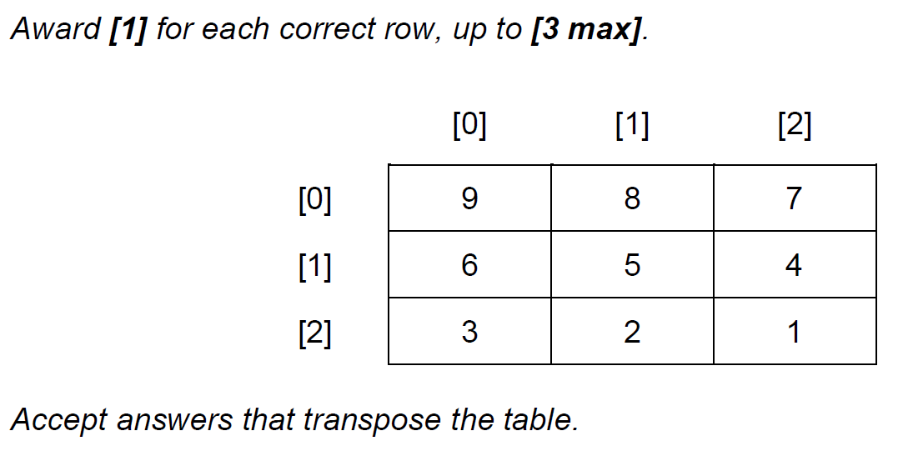

There are many different ways of placing the numbers 1 to N2 into an N × N two-dimensional array.  
 The following two-dimensional array, with dimensions 5 × 5 has been filled in a circular  
 (spiral) pattern with numbers 1 to 52.

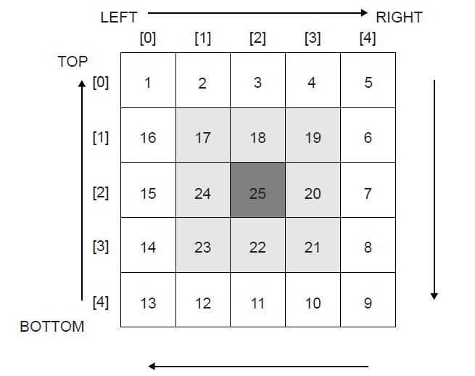

The general process of filling an N × N two-dimensional array, in a circular (spiral) pattern,  
with numbers from 1 to N2 could be described as follows:

• initialize Z=1,

• initialize TOP, BOTTOM, LEFT and RIGHT,

• iterate until the whole array is filled,

• each time Z is placed correctly increase the value of Z by 1,

• fill the elements of the TOP row starting from LEFT to RIGHT,

• increase TOP by 1 before filling the elements of the RIGHT column,

• fill the elements of the RIGHT column starting from TOP to BOTTOM,

• decrease RIGHT by 1 before filling the elements of the BOTTOM row,

• and continue filling the BOTTOM row and LEFT column in a similar way,  
 adjusting TOP, RIGHT, BOTTOM and LEFT accordingly.

1. (i) State the initial values for TOP, BOTTOM, LEFT and RIGHT. [1]

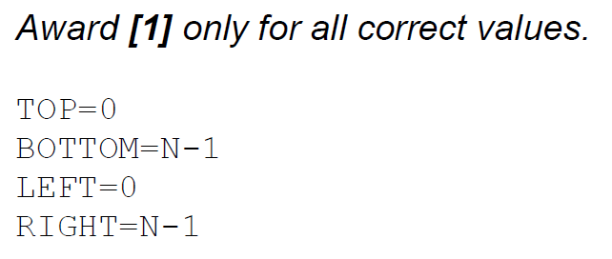

(ii) State the consequence of not increasing TOP by 1 before starting to fill the  
 elements of the RIGHT column. [1]

The array element at position [TOP][RIGHT] in which value of Z is already placed, will be overwritten by the value of Z + 1;

Not all of the numbers 1 to N2 will be placed in the array because some will be overwritten;

The array will be filled with more than N2 numbers/with numbers greater than N2;

*Accept answers from the sample 5*×*5 table, eg the value of MATRIX[0][4] which is already filled by 5, will be changed to 6.*

(iii) In the algorithm described above, state the indices (subscripts) of the first and  
 the last element to be filled in the BOTTOM row. [1]

The first element to be filled in BOTTOM row has indices (subscripts) [BOTTOM][RIGHT] and the last to be filled has indices (subscripts) [BOTTOM][LEFT];

*Accept answers from the sample 5* × *5 table. The first element to be filled in BOTTOM row has indices (subscripts) [4][3] and the last to be filled has indices (subscripts) [4][0].*

1. Construct, in pseudocode, an algorithm to fill an N × N two-dimensional array, in a

circular (spiral) pattern, with numbers from 1 to N2 as described above. [9]

*Award up to* ***[9 max]*** *as follows.*

*Award* ***[1]*** *for initializing Z.*

*Award* ***[1]*** *for initialization of the top and bottom rows, and left and right columns.*

*Award* ***[1]*** *for the outer loop (must be while).*

*Award* ***[1]*** *for the idea that four inner loops are needed*

*(could be for or while loops).*

*Award* ***[1]*** *for each correct inner loop up to* ***[4 max]****.*

*Award* ***[1]*** *for assignment (current value of Z placed in A).*

*Award* ***[1]*** *for changing the value of Z after each assignment.*

*Award* ***[1]*** *for changing values of TOP, BOTTOM, LEFT, RIGHT.*

